Stock Price Movement Prediction Using Hybrid LSTM-Transformer Models – Milestone 4

Introduction
One of the most difficult problems is market prediction due to unpredictability and fluctuation of stock markets [1]. Prices of the market are affected by various factors such as economic indicators, investor sentiments and geopolitical occurrences that make it hard to predict prices. Artificial intelligence has been used in recent years to learn based on large datasets in financial analysis [2]. AI models have superior abilities of modeling non-linear relationships and time-lags compared to statistical techniques.
Traditional methods, such as linear regression and time-series analysis, are not as effective in capturing the dynamic and complicated nature of stock market data [3]. These methods are founded on unlikely assumptions in financial markets, and are weak predictors. More recent studies have investigated the application of deep learning models, such as Long Short-Term Memory (LSTM) and Transformers. Transformers can learn long-term dependencies based on attention mechanisms, unlike LSTM models that can learn short-term sequential patterns.
This study aims to develop a dependable stock price movement prediction model based on a combination of an LSTM and a Transformer model. The research also seeks to apply the most effective model in a web interface to make it user-friendly. This research will achieve the following main goals as pre-processing the stock price history of SPY, training and comparing deep learning networks, measuring their performance appropriately, and testing their performance on unknown data.

Background and Problem Definition
Financial data in the form of a time series is very complex, as financial markets are dynamic and unpredictable [4]. The stock returns are non-linear, noisy and exhibit volatility clustering, such that large moves are likely to be succeeded by other large moves and therefore not easy to predict over a period of time [5]. Market volatility is usually quantified using volatility indices like the CBOE Volatility Index (VIX), which changes on a daily basis and is a gauge of anticipated volatility by investors. A value of 18-20 indicates moderate risk but extreme event spikes. It is also known that stock returns are extremely volatile, and returns of over 1 per cent occur 16% of the time in the S&P 500 index data set. These statistical characteristics underline the challenges in modelling financial markets with simple models. In this research, the task is to predict the short-term (5-day) stock price change. This is a classification problem in which prediction is done for whether the future return will be positive or negative. The task is difficult due to the weaker market signals in the short term and the impact of random external events, resulting in limited predictability and uncertainty.
While numerous studies have explored deep learning models, there is a lack of research on combining sophisticated deep learning models with financial domain knowledge. Existing models like ARIMA and GARCH model volatility well, but lack sophistication in capturing complex patterns, while applying LSTM or Transformer models separately can capture short-term and long-term dependencies but not both simultaneously. [6]. Few works explore hybrid models with a rich set of technical indicators, and test them on real data. The importance of this research is to overcome these gaps by proposing a hybrid LSTM-Transformer architecture with a combination of sequential and attention-based learning. This model aims to increase the accuracy of forecasting and provide a more powerful framework of financial forecasting. The results of this research are applicable in improving trading, risk management and investment planning as they give insights into the short-term market dynamics.

Literature Review

3.1 Financial Data Preprocessing and Feature Engineering
Financial time-series data should be preprocessed to remove noise; ‌Bilal, et al., (2022) propose that automated preprocessing pipelines help to increase consistency with missing value treatment, normalisation and alignment [7]. However, this may overlook domain-specific characteristics like market shocks. Still, regarding the same point, Linardatos, et al., (2020) assert that statistical filtering and neural transformations which are mixed preprocessing frameworks enhance stability [8]. However, it can also cause increased computational expenses along with reduced interpretability.
The importance of feature engineering is to increase the accuracy of prediction. Ailyn, (2024) argues that features that are engineered such as returns and volatility indicators enhance deep learning convergence significantly. However, Cunha, et al., (2025) observe that excess or unrelated features may reduce model performance since it may be redundant and noisy. Likewise, Yadav and Giri, (2025) stress the role of technical indicators such as RSI, MACD and moving averages, claiming they capture the market trends well. The use of multiple indicators can result in overfitting, particularly when the feature selection is not optimal.
Thus, although feature engineering enhances prediction accuracy, the key is to strike a balance between features and model generalisability. Hence, this justifies the aim of this research to use selected technical indicators for stock prediction.

3.2 Deep Learning Models for Stock Market Prediction
The use of deep learning models has increased due to their capability to capture nonlinear financial data relationships. LSTM is a popular model for time-series forecasting. Yang, (2025) suggest that LSTM models capture the dependencies and enhance the prediction when combined with financial features. But because of the sequential nature, LSTM has difficulties with long-term dependencies. To overcome this, several mechanisms have been incorporated. Wen and Li, (2023) introduce an LSTM-attention model, which improves feature extraction by emphasising key timestamps. But, due to increased complexity, it may overfit noisy data. Conversely, Transformer models use only self-attention. According to Su, et al. (2025), Transformer models are superior to conventional models because they are capable of capturing long-term dependencies and multiple temporal patterns [9]. But they have high computational demands.
Hybrid models strive to merge both methods. Based on the study by Cao, et al., (2024), hybrid LSTM-Transformer models are more stable and accurate due to the combination of sequential processing and attention [10]. On the other hand, some research suggests that hybrid models add to the complexity of the model without necessarily improving performance in all cases.
Thus, although deep learning models provide better performance, their performance is contingent on dataset quality, features extracted, and model architecture. This is the aim of evaluating LSTM, Transformer and hybrid models.

3.3 Model Evaluation and Reliability in Financial Prediction
Evaluation of stock prediction models is beyond conventional measures. According to Polamarasetti, et al., (2022), classic measures such as accuracy and RMSE are inadequate to assess how useful the models are in making financial forecasts [11]. They suggest directional accuracy and F1-score to be more suitable for trading. However, numerous papers only offer a partial model analysis.
Comparative analyses give additional information. Ahmed, et al., (2023) reveal that deep learning models tend to outperform the conventional ones but the effectiveness is dependent on the dataset [12]. Similarly, the Transformer models are good at capturing the long-term dependencies, but are not necessarily superior in all the cases to the simpler models. This means that there is different model performance.
Hasan, et al., (2023) report that hybrid models are more resilient in different financial markets [13]. However, deep learning models are less interpretable and costly to execute, which makes their application challenging. Generalisation is another important consideration. The models developed based on specific datasets do not apply to diverse market conditions. Further, the significance of testing models across time.
Therefore, model assessment must take into account various measures and testing scenarios, which is in line with the purpose of testing model performance with new data and in the uncertainty of markets.

3.4 Research Gap and Summary
Stock market prediction research has certain gaps. On the one hand, studies focus on either of the three, preprocessing, model building, or testing. Alternatively, these aspects are not integrated. Also, a large number of studies do not involve various data and the analysis of out-of-sample or noisy data which reduces their applicability. There is also an inconsistency in the evaluation measures among studies, which makes it difficult to compare them.
This study addresses these shortcomings through advanced feature engineering, combining deep learning models, and testing on a variety of metrics and real data. It combines preprocessing, modelling and testing in order to improve the accuracy of prediction. Besides, studies determine the importance of feature engineering, deep learning models, and evaluation. However, such problems as noise, complexity and generalisation remain.

Data Acquisition and Exploration

4.1 Data Source (Yahoo Finance, SPY)
This study used the library of yfinance to obtain the data from Yahoo Finance. The investment selected is SPY, which tracks the S&P 500 index and is a mirror of the behaviour of the US stock market [14]. This asset selection ensures that the data reflects the behaviour of the market in general rather than the peculiarities of the stock. From January 2010 to January 2025, past daily values were collected. This period provides sufficient variability and has different market cycles, such as growth, volatility and uncertainty. This dataset includes common financial variables including Open, High, Low, Close (price) and Volume, commonly used in finance.
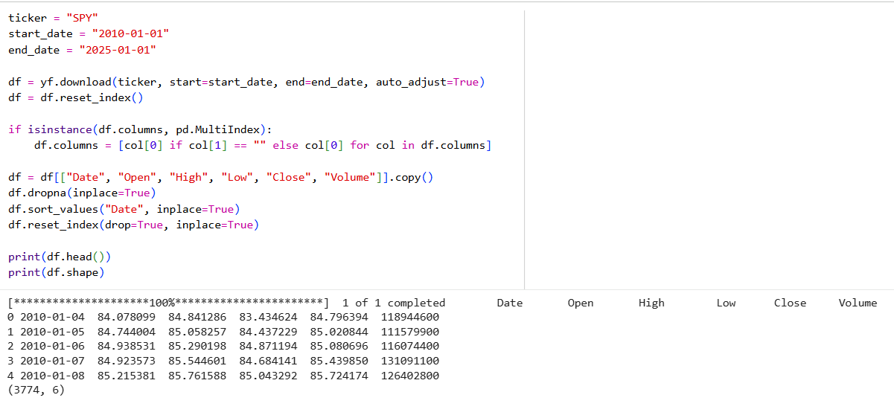
Figure 1: Data Collection and Preprocessing

4.2 Dataset Description
After the first data collection, the total observations in the dataset were 3,774 and six important attributes were included: Date, Open, High, Low, Close and volume. Data were pre-processed by removing the missing observations and putting the dates in chronological order to ensure that there is temporal consistency [15]. The data comes in the form of a time series, where a row is a day. The numerical features are continuous and the Date feature is viewed as a temporal index. The data show price and volume variations, indicating dynamic market activity. This led to additional processing and feature engineering to enhance the predictability.

4.3 Feature Engineering
Several features were developed to improve the performance of the model. Price characteristics include price daily returns (1-day, 3-day, 5-day, and 10-day) to indicate short-term price changes. The other characteristics are open-close, high-low and daily gap between closing prices, which are also taken into consideration to capture the intraday and interday trends.
Technical indicators were also incorporated to get better insights. These are Simple Moving Averages (SMA), Exponential Moving Averages (EMA), Relative Strength Index (RSI), Stochastic Oscillator, Moving Average Convergence Divergence (MACD), Bollinger Bands and Average True Range [16]. They are applied to record the trends, momentum and volatility. However, it is also possible to overfit and produce excessive features.

4.4 Target Variable Creation
The target variable was a five-day forward return. This was ascertained by comparing the future closing price and the current closing price. A band of ±0.2% was taken as a neutral to remove minor variations and noise. Any observations that returned within this range were eliminated to facilitate more classification of the classes. The target variable was then binary-encoded as an upward move (1), or a downward or no movement (0). This simplifies the prediction problem and makes it more applicable to trading strategies.
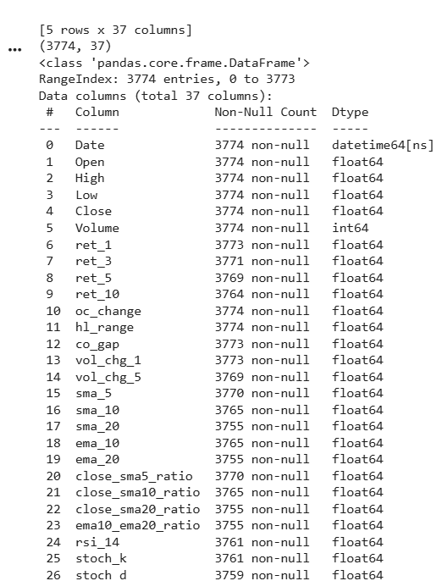
Figure 2: Dataset Description
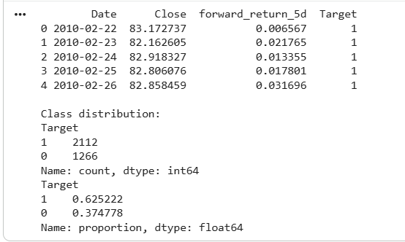
Figure 3: Target Variable

4.5 Data Splitting
To have realistic model evaluation data was partitioned into training, validation and test sets. This yielded 70 % f the data to be used on training, 15% on validation, and 15% on testing. This time separation eradicates information leakage and makes sure that no future information is utilised to train models [17]. StandardScaler was used to scale the features and fitted on the training set, then used on the validation and test sets. Moreover, a 30-day window was employed to allow time-series learning where models learned based on the history.
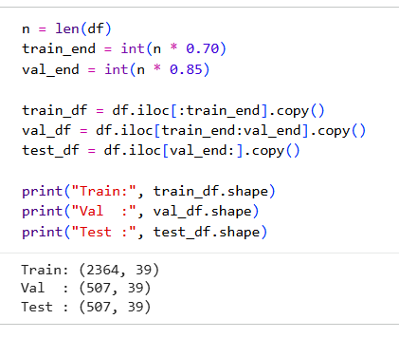
Figure 4: Train-Test-Validate

4.6 Exploratory Insights
The preliminary data analysis indicated an uneven distribution of the target variable, with 62% of the observations being upward movements and 38% downward movements. This indicates that there is a small positive market trend in the selected period. The volatility analysis showed more variability, such as when there was a crisis in the market, which can affect the model training. The weak signals and noise complicate stock price prediction. These results justify more advanced feature engineering and deep learning techniques to improve prediction.

Methodology and Model Development

5.1 Data Preprocessing (Scaling, Sequences)
The data gathered needed to be pre-processed for use in deep learning. First, remove any missing values that arose due to feature engineering. The dataset includes features with varying magnitudes, so the data were normalised using StandardScaler. This normalises the data to have a mean of zero and standard deviation of one, facilitating faster convergence and avoiding the influence of features with larger magnitudes.
For time-series training, the data were transformed into sequences. A rolling window was used, with each sample being the past 30 days of feature values to predict the next outcome. The length was chosen to allow for short-term dependency without adding too much computational burden. This initial step transformed the data to a three-dimensional shape (samples, sequence length, features), which can be directly used by both recurrent and attention mechanisms. This is essential as financial data may have patterns influenced by past events.

5.2 LSTM Model
The Long Short-Term Memory (LSTM) model was used to model time-based patterns in financial data. LSTM is a variant of recurrent neural networks that can overcome the vanishing gradient issue and store information [18]. The architecture in this study comprises an LSTM layer with a hidden state of 64 units, and a dropout layer to prevent overfitting. The output is then processed by a fully connected layer with two neurons corresponding to the two classes.
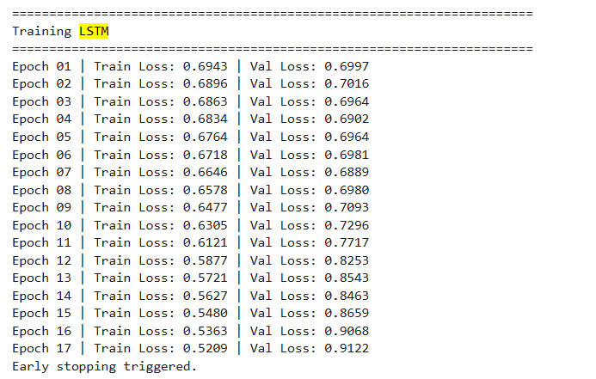
Figure 5: LSTM Model - Training
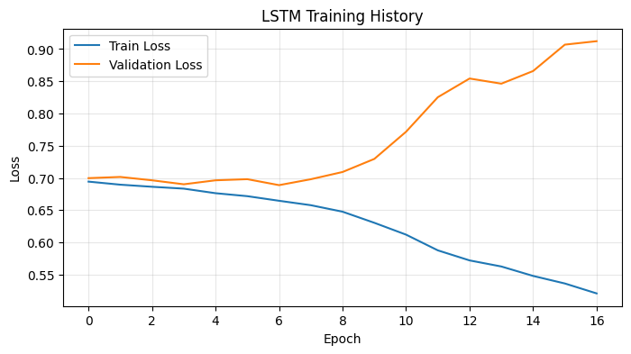
Figure 6: LSTM - Training History
The LSTM operates on the sequences step by step and learns local patterns. But its sequential processing makes it less effective in capturing long-term dependencies. However, LSTM is suitable for modelling short-term trends and can be used as a reference model.

5.3 Transformer Model
The Transformer model is implemented to overcome the limitations of sequential processing in LSTM. Transformers apply self-attention to process data at all time steps in parallel. This gives it the ability to model long-range dependencies and intricacies in the data set.
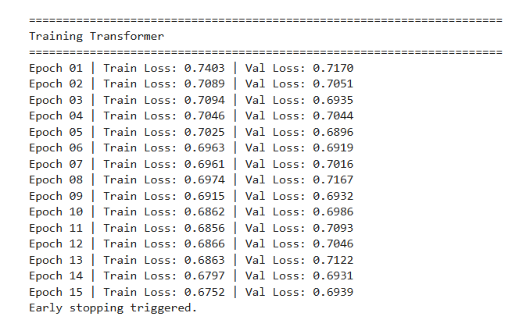
Figure 7: Transformer Model - Training
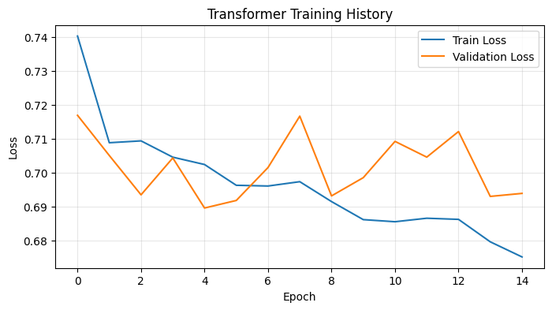
Figure 8: Transformer - Training History
The model has an input projection layer to map the features to a higher-dimensional space, and a positional encoding layer to maintain temporal relationships [19]. The input sequences are then processed by a Transformer encoder with multiple attention heads and feedforward layers. Dropout regularisation is used to prevent overfitting, and the output is a fully connected layer for classification. This model is well-suited to capturing long-range dependencies and global information. But it is more computationally intensive and could struggle with noisy or sparse data.

5.4 Hybrid Model (LSTM-Transformer)
To combine the benefits of both models, an LSTM-Transformer hybrid model was implemented. It begins with an LSTM to capture local sequential and short-term relationships. This is followed by a linear projection to an appropriate dimension, feeding into a Transformer encoder. The Transformer layer helps to capture long-range relationships using self-attention. The representation is fed into fully connected layers with ReLU activation and dropout regularisation. This design seeks to address the respective shortcomings of LSTM and Transformer models by integrating temporal and attention-based context modelling.
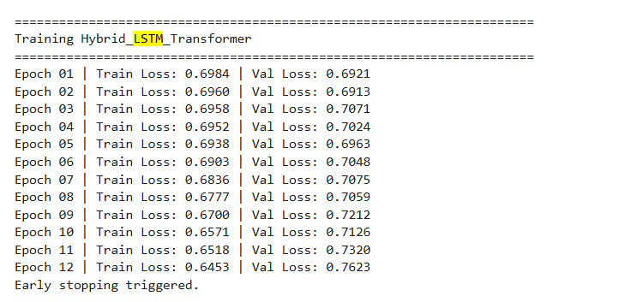
Figure 9: Hybrid LSTM Transformer – Training
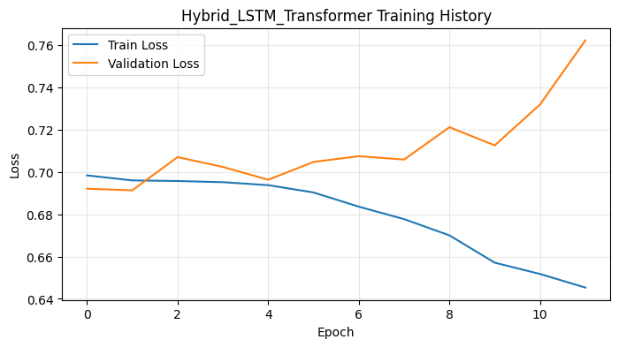
Figure 10: Hybrid LSTM Transformer - Training History
The hybrid model has the potential to be more effective, but this comes at the cost of increased complexity. So, its success hinges on whether the increased complexity translates to better performance.

5.5 Design Choices
The model is designed to perform well while being efficient, with a sequence length of 30 days and 28 features to prevent overfitting. Training with AdamW optimiser and a learning rate of 0.0005 is stable. Weighted loss addresses skewed class distributions and dropout and early stopping enhance generalisation. Threshold optimisation also improves classification accuracy.

Evaluation and Testing

6.1 Training Setup
PyTorch was used to implement the models and train them in a GPU environment for speed. To avoid data leakage, the data were split chronologically into training (70%), validation (15%) and test (15%) sets. Mini-batches were used in training with a batch size of 32, which allowed for faster training while ensuring model stability. Models were trained for up to 40 epochs. But early stopping was used based on the validation loss with a patience of 10 epochs to avoid overfitting. The learning rate was adjusted (ReduceLROnPlateau) based on the validation loss.

6.2 Hyperparameters
Hyperparameters were chosen through experimentation and deep learning guidelines. The learning rate was chosen to be 0.0005, to ensure convergence without overshooting the target. The weight decay was set to 1e-4 to prevent overfitting. The LSTM model had a hidden size of 64, and the Transformer model had a model dimension (d_model) of 64, 4 attention heads and 2 layers of encoders. The hybrid model used this setup with a single LSTM layer followed by a Transformer encoder layer [20]. All models used a dropout of 0.2 to enhance generalisation. These hyperparameters were selected to balance model complexity and computational resources.

6.3 Class Imbalance Handling
The statistics were balanced having approximately 62 percent upward and 38 percent downward movements. To address this issue, the weights of the classes were estimated based on the training data and employed in the cross-entropy loss function [21]. The weights were approximately 1.34 and 0.80 in the minority and the majority respectively. This made this model not to be skewed towards the majority group. This enabled the model to learn more the minority class which is necessary in financial predictions where both the positive and negative trends must be predicted correctly.

6.4 Evaluation Metrics
The performance of the models was evaluated on several metrics. Accuracy was used as overall accuracy and balanced accuracy included imbalance in the classes by averaging the recall. F1-score was selected to be macro because it considers both classes equally and is hence suitable with unbalanced data. Class weight was taken into account in terms of the weighted F1-score. ROC-AUC has also been calculated in order to evaluate the performance of the model to differentiate between classes with different thresholds. Class-specific precision and recall were also computed to investigate the model performance in regards to predicting up and down motions.

6.5 Threshold Tuning
The model was fine-tuned in terms of the threshold, with a range of 0.35 to 0.65, and the best one was chosen by considering the macro F1. The optimal threshold was found to be around 0.46 for the LSTM and Transformer models, and 0.48 for the hybrid model. This helped to balance out the classification and enabled the model to better detect both the majority and minority classes. Threshold optimisation is crucial in financial trading, where the cost of misclassification can depend on market factors.

6.6 Testing on New Data
To assess the generalisation ability, the top-performing model (Transformer) was further tested on new data from 2025 to 2026. The model scored an accuracy of around 55.4%, a macro F1 score of 0.45 and an ROC-AUC of 0.46. The model retained good performance, but showed a significant drop in performance in comparison with the test set. This suggests that financial markets are ever-evolving, and models trained on past data may not be able to keep up with market changes. These findings suggest the need for regular model retraining and validation in practice.

6.7 Challenges
There were a number of challenges with model evaluation. The main challenge was the volatility of financial data, which hampers forecasting. The imbalance of classes also presented a problem, necessitating the use of weighted loss functions. There was also evidence of overfitting in some models, such as the LSTM, which exhibited an increase in validation loss after a few epochs. Furthermore, the models tended to favour upward movements, possibly due to the upward trend in the data. Lastly, generalisation was an issue with performance dropping on new data, showing the challenges of developing accurate financial models.

Results and Analysis

7.1 Model Comparison
Several metrics were used to compare the performance of the LSTM, Transformer and hybrid LSTM-Transformer models. The Transformer model had an accuracy of around 60.8% and a macro F1 of 0.52, which was higher than the LSTM model with lower accuracy (~45.7%) and macro F1 (~0.45). The hybrid model had the best accuracy (65.2%), but its macro F1-score (0.51) was slightly lower than that of the Transformer. This suggests that while the hybrid model boosted the accuracy of the model, it did not boost class balance. The Transformer model achieved a better balance between overall accuracy and class performance, and was the most accurate model overall.
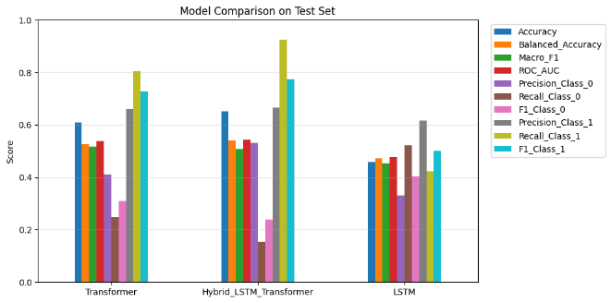
Figure 11: Model Comparison

7.2 Key Findings
The results provided some key insights. First, there were patterns in the data that deep learning models were able to learn, but there was only a small improvement in performance over baseline models. Second, the Transformer model achieved better performance than LSTM, highlighting its effectiveness in capturing long-term dependencies through attention. Third, the hybrid model led to better accuracy but was heavily skewed towards predicting an upward movement (recall for positive class >0.92). But it had a very low recall for the negative class (~0.15), which means it poorly identified downward movements. This shows the challenge of modelling the minority class in financial data.

7.3 Volatility Analysis
The performance was also analysed in the conditions of high volatility (the highest 25% of volatility values) to further test the models. The hybrid model had the superior performance in accuracy (~67.5) and macro F1-score (~0.55) showing that it was better suited to unsteady conditions. In this case, the Transformer model was found to be accurate (~66.7%) but was poorly recalling the negative class (~ 0.08), indicating that it was not very efficient in recognizing downward movements during volatility. The LSTM model had a consistent performance of approximately 49% accuracy. These results reveal that despite the fact that hybrid models can be used to capture complex patterns in volatile conditions, the models still struggle to make balanced predictions.

7.4 Generalisation Results
The model performance in the generalisation of the new data in 2025-2026 was analysed. Transformer model, which was selected as the best model, had an accuracy of approximately 55.4, a macro F1-score of 0.45, and an ROC-AUC of 0.46. This is a huge decline in performance as compared to the test set results and is an indication that the model did not generalise well in the shifting market environment. This decline indicates how dynamic the financial markets are where the past trends might not be the same. It is also a sign that the model could have overfitted historical data to a certain degree.

7.5 Overall Analysis
These results demonstrate that deep learning models can be more accurately predictive, yet remain limited in terms of financial feasibility. All the models tended to predict price growth, perhaps because of the imbalance in the data in terms of classes. Although methods like weighted loss and threshold tuning, which were not necessarily successful, were used. Furthermore, the low macro F1-scores (around 0.5) indicate that the performance of the classification is in the range of just above random guessing in a binary classification problem. Although the hybrid model was the most accurate, it did not perform significantly better than the Transformer in terms of overall performance. This result shows that more complex models are not always effective. The decline in the performance of the test set also highlights the issues of generalisation in financial forecasting since market conditions are dynamic.
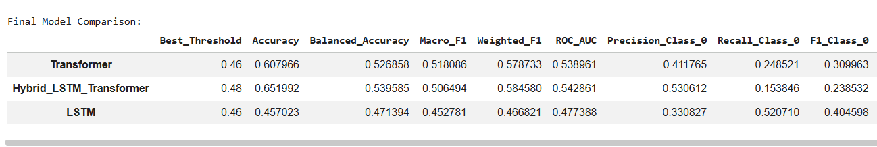
Figure 12: Overall Metrics for Models
In general, the findings indicate that although the proposed models acquire certain habits using the stock data, they cannot yet be used to make crucial decisions. In order to make better models in the future, feature engineering, external sources of data and adaptation of models to the market changes should be taken into consideration.
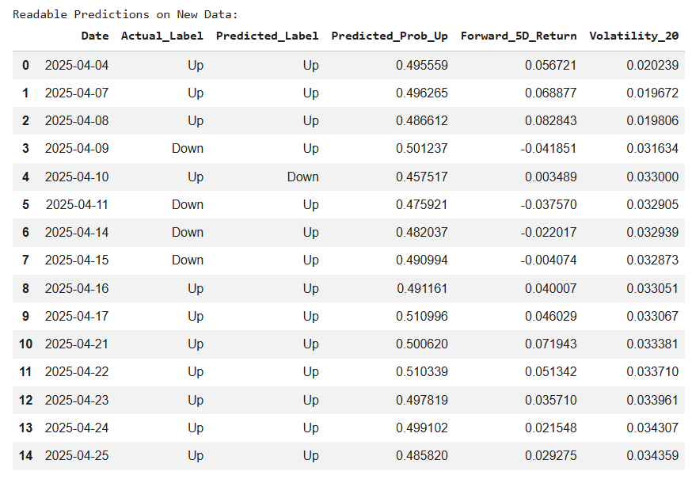
Figure 13: Predictions on New Data
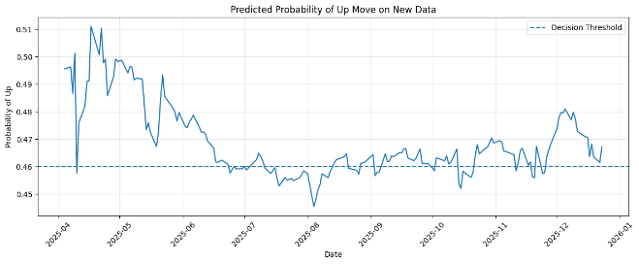
Figure 14: Predicted Probability on New Data

Deployment

8.1 Platform (Hugging Face)
The trained model was released on Hugging Face Spaces, a social site to share machine learning models. It has tools such as Streamlit and Gradio and can be easily deployed without infrastructure. Scaler and configuration files and trained Transformer model were uploaded. This allows the model to be used with a web application, and any user can use the system without any knowledge of programming. The platform has versioning/update features, making it possible to continuously develop it.

8.2 Application Workflow
There is a workflow in the deployed application. The user interface allows the user to input data or make a selection. The data is then preprocessed, which involves scaling of the features with the StandardScaler that was used in training and sequences generated with a 30-day window. This information is then inputted into the trained Transformer model, which gives the probability scores of the likelihood of the stock price increasing. Thresholding of the probabilities generates Up/Down predictions. The output of the model is then available to the user in a simple-to-understand form that indicates the class prediction, the confidence of the prediction and other details like the volatility and expected return.
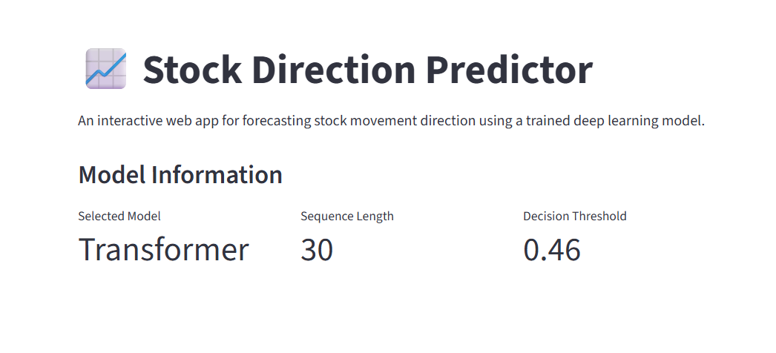
Figure 15: Stock Price Prediction - App UI

8.3 User Interaction
It has a user-friendly user interface. Depending on the complexity of the application, the user can input by typing or uploading a file. Once the data is typed, the user can then press a button to be given a prediction. The outcome is then provided indicating the direction the model predicts the trend to take higher or lower and the confidence score. Additional information such as probability and recent trend can be availed to enhance the understanding. The method enables non-technical users to easily understand and apply the predictions of the model.
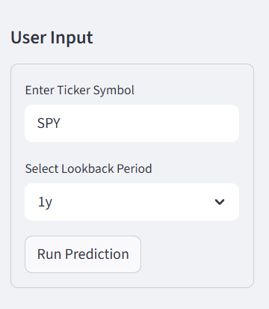
Figure 16: User Interaction in App

8.4 Testing
The developed application was tested using past and new inputs to check the accuracy. Experiments on the model were conducted under varying market conditions to determine how well the model performs under various volatility. These were compared to real-world results to verify consistency of the prediction. This system was found to be consistent in behaviour with the predictions being in line with the earlier model results. However, there were also inconsistencies, particularly when there is a sudden shift in the market, which is a typical problem with financial forecasting. To conclude, the deployment process is successful in translating the model into a usable app that can be tested and applied in the real world.
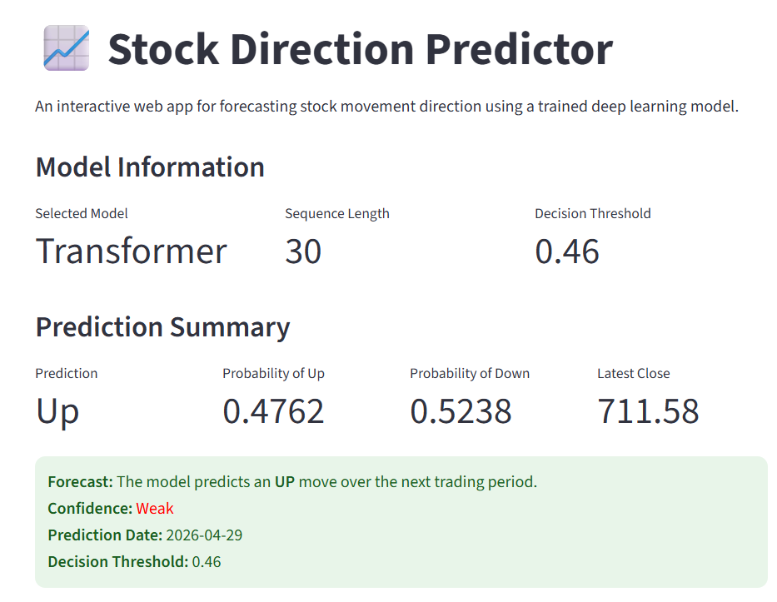
Figure 17: Prediction Screen
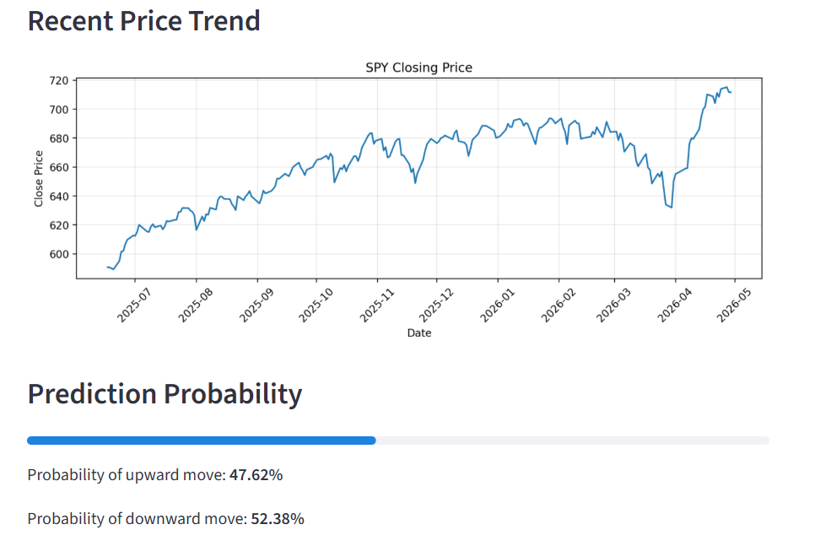
Figure 18: Trend Prediction along with probability
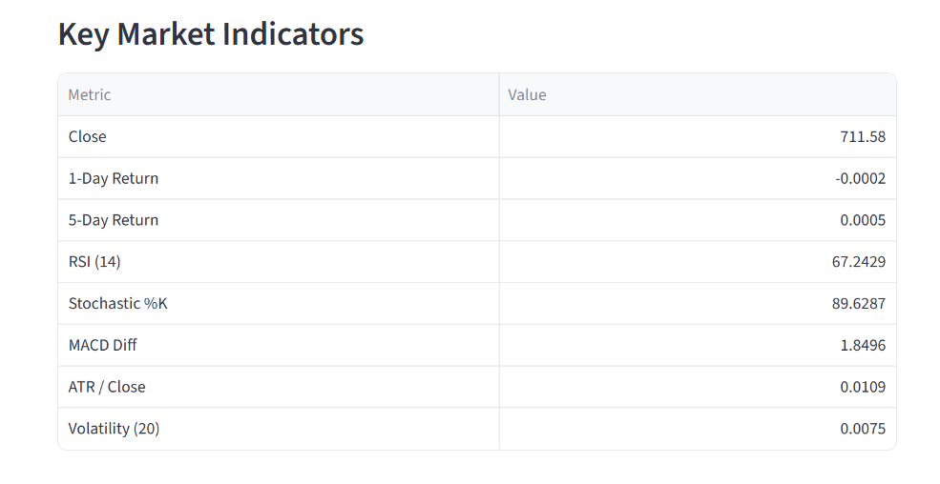
Figure 19: Key Market Indicator Prediction
The testing stage of the deployed application involved confirmation of the user interface and visualisation of predictions, which indicated the correct functioning of the end-to-end system. The app helps to check that the trained Transformer model is implemented and utilized to make predictions. The outputs display model information, prediction (Up/Down) and
probability score, which is the certainty of the prediction. The app also provides data on the latest trends in the market, the RSI, MACD, and volatility, which can be useful to interpret. These not only assist in making predictions that are not only binary, but also interpretable with financial understanding. The effectiveness of the model is verified by the correlation between the predictions and the decision-making depending on the decision threshold. However, under extreme market conditions, inconsistencies are observed and this indicates that the model must be retrained and additional features must be added so that it can predict better.
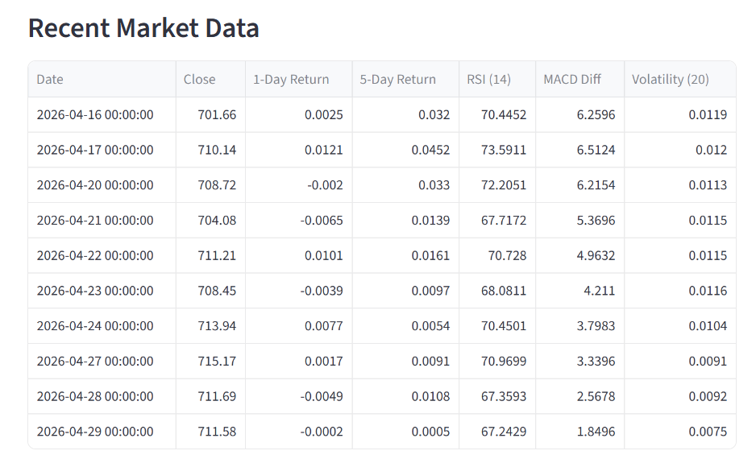

Conclusion and Recommendations

9.1 Key Findings
Deep learning models were trained and tested to predict stock price movements based on SPY data. The findings revealed that the Transformer model offered the most balanced results in terms of accuracy and class-specific performance, whereas the hybrid model had the highest accuracy but was affected by class imbalance. The key to enhancing prediction performance was feature engineering, which allowed the models to better capture trend, momentum and volatility patterns by incorporating technical indicators.
However, while these techniques improved performance, the overall results were still moderate, with macro F1-scores of about 0.5, suggesting that the ability to balance classification were limited. There was also a tendency towards predicting up movements, which is a consequence of both class imbalance and market dynamics. Additionally, the drop in performance with new unseen data suggests generalisation difficulties in financial modelling. These results indicate that although deep learning models can learn valuable information, they are still limited by the unpredictable, volatile and noisy nature of financial markets. Hence, obtaining high performance in practice is difficult.

9.2 Recommendations
Recommendation 1: Use of Multi-Source Data
Other data sources such as macroeconomic data, financial news and sentiment analysis should be used as models. Price data of the past cannot be used by itself to accurately predict the price of stocks since stock markets are influenced by external factors. A combination of structured financial data and unstructured textual data might provide more information and result in improved model performance.
Recommendation 2: Ensemble Methods
Ensemble learning algorithms can be used to improve stability of prediction and mitigate bias in models. Instead of depending on a single model, ensemble models, such as that based on LSTM and Transformer, among other machine learning models, can be used to improve predictions. Integrating models through models such as stacking or boosting can exploit the strengths of multiple models and alleviate the weaknesses of single models, to produce improved predictions.
Recommendation 3: Regular Model Retraining
Market relations and situations are subject to change. Therefore, new data should be retrained on models on a regular basis. It is possible to increase the adaptability and performance by establishing a learning framework where the model is updated with new data periodically. This assists in maintaining the model in sync with market dynamics and eliminates drift.
Recommendation 4: Better Feature Selection and Dimensionality Reduction
In future studies, feature selection should be incorporated in order to trim redundancy and improve the performance of models. The important features can be identified with the help of methods such as the Principal Component Analysis (PCA) or feature importance. Dimensionality reduction may also simplify the computation, eliminate overfitting, and enhance model explainability, which can be converted into better model accuracy.

Conclusion
As seen in this research, deep neural networks, and Transformer-based models, in particular, can be used to predict the stock market due to their ability to learn complex temporal relationships and non-linearity in financial data. The volatility, randomness and uncertainty of the stock market limit their performance. The results indicate that the models had a fair level of performance in prediction, but in retaining balanced classification and generalisation in new data. This means that these systems are limited in their performance by using past price features only. Importantly, the findings also indicate that although the complexity of a model (hybrid models) can be increased to enhance performance, it is not always so, especially when data quality and feature relevance are limitations.

References

[1] | S. M. Idrees, M. A. Alam and P. Agarwal, "A prediction approach for stock market volatility based on time series data," IEEE Access, vol. 7, pp. 17287-17298, 2019.
[2] | O. Cherevko, O. Shlapak, Y. Kostynets, M. Pasichnyi and I. Prokhorov, "The role of artificial intelligence in financial analysis and forecasting: Using data and algorithms," Data and Metadata, vol. 3, p. 3, 2024.
[3] | H. Zheng, J. Wu, R. Song , L. Guo and Z. Xu, "Predicting financial enterprise stocks and economic data trends using machine learning time series analysis.," 2024.
[4] | N. B. M. Dawi, M. Matejicek and P. Maresova, "Unraveling financial market dynamics: The application of fractal theory in financial time series analysis," Fractals, vol. 33, no. 1, p. 2550017, 2025.
[5] | J. V. Saenz, F. M. Quiroga and A. F. Bariviera, "Data vs. information: Using clustering techniques to enhance stock returns forecasting," International Review of Financial Analysis, vol. 88, p. 102657, 2023.
[6] | G. Taneva-Angelova and D. Granchev, "Deep Learning and Transformer Architectures for Volatility Forecasting: Evidence from U.S. Equity Indices," Journal of Risk and Financial Management, vol. 18, no. 12, p. 585, 2025.
[7] | M. Bilal, G. Ali, M. W. Iqbal, M. Anwar, M. S. A. Malik and R. Abdullah, "Auto-prep: efficient and automated data preprocessing pipeline," IEEE Access, vol. 10, pp. 107764-107784, 2022.
[8] | P. Linardatos, V. Papastefanopoulos and S. Kotsiantis, "Explainable AI: A Review of Machine Learning Interpretability Methods," Entropy, vol. 23, no. 1, p. 18, 2020.
[9] | L. Su, X. Zuo, R. Li, X. Wang, H. Zhao and B. Huang, "A systematic review for transformer-based long-term series forecasting.," Artificial Intelligence Review, vol. 58, no. 3, p. 80, 2025.
[10] | K. Cao, T. Zhang and J. Huang, "Advanced hybrid LSTM-transformer architecture for real-time multi-task prediction in engineering systems," Scientic Reports, vol. 14, no. 1, p. 4980, 2024.
[11] | A. Polamarasetti, R. Vadisetty, S. Vangala, P. Chinta, K. Routhu, V. Velaga, C. Moore and S. Boppana, "Evaluating machine learning models efficiency with performance metrics for customer churn forecast in finance markets," International Journal of AI, BigData, Computational and Management Studies, vol. 3, no. 1, pp. 56-65, 2022.
[12] | S. Ahmed, M. Alam, M. Hassan, M. Rozbu, T. Ishtiak, N. Rafa, M. Mofijur, A. S. Ali and A. Gandomi, "Deep learning modelling techniques: current progress, applications, advantages, and challenges," Artificial Intelligence Review, vol. 56, no. 11, pp. 13521-13617, 2023.
[13] | S. Hasan, I. Zerine, M. Islam, A. Hossain, K. Rahman and Z. Doha, "Predictive Modeling of US Stock Market Trends Using Hybrid Deep Learning and Economic Indicators to Strengthen National Financial Resilience," Journal of Economics, Finance and Accounting Studies, vol. 5, no. 3, pp. 223-235, 2023.
[14] | Y. Finance, "SPDR S&P 500 ETF (SPY) stock historical prices and data," Yahoo Finance, 2026. [Online]. Available: https://uk.finance.yahoo.com/quote/SPY/history/. [Accessed 30 April 2026].
[15] | L. Gauer, K. Chanard and L. Fleitout, "Data-driven gap filling and spatio-temporal filtering of the GRACE and GRACE-FO records," Journal of Geophysical Research: Solid Earth, vol. 128, no. 5, p. e2022JB025561, 2023.
[16] | P. Yadav and J. N. Giri, "Technical Analysis Vs Fundamental Analysis: A Comparative Study of Bollinger Bands, RSI and MACD Against Fundamental Factors in Commodity Trading," Journal of Marketing & Social Research, vol. 2, pp. 323-329, 2025.
[17] | S. Albelali and M. Ahmed, "Hidden Leaks in Time Series Forecasting: How Data Leakage Affects LSTM Evaluation Across Configurations and Validation Strategies," arXiv preprint, p. arXiv:2512.06932, 2025.
[18] | S. Al-Selwi, M. Hassan, S. Abdulkadir and A. Muneer, "LSTM inefficiency in long-term dependencies regression problems," Journal of Advanced Research in Applied Sciences and Engineering Technology, vol. 30, no. 3, pp. 16-31, 2023.
[19] | H. Irani and V. Metsis, "Positional encoding in transformer-based time series models: A survey," arXiv preprint, p. arXiv:2502.12370, 2025.
[20] | K. L. Tan, C.-P. Lee, K. Anbananthen and K. M. Lim, "RoBERTa-LSTM: a hybrid model for sentiment analysis with transformer and recurrent neural network," IEEE Access, no. 10, pp. 21517-21525, 2022.
[21] | G. Polat, I. Ergenc, H. Kani, Y. Alahdab, O. Atug and A. Temizel, "Class distance weighted cross-entropy loss for ulcerative colitis severity estimation," Annual Conference on Medical Image Understanding and Analysis, pp. 157-171, 2022.

